* **Registering a domain**

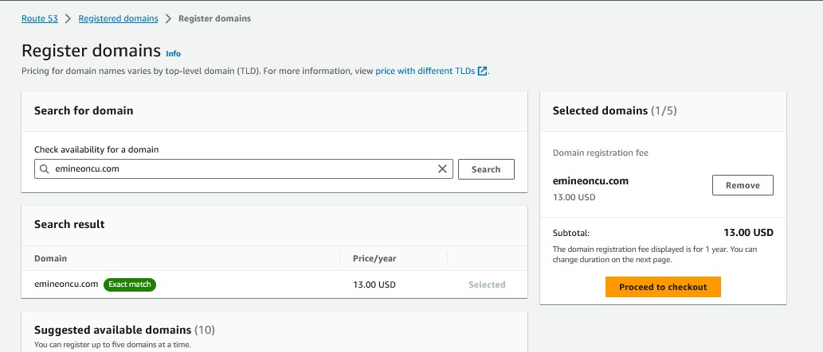

* **Auto Renew is OFF, so won't get charged next year.**

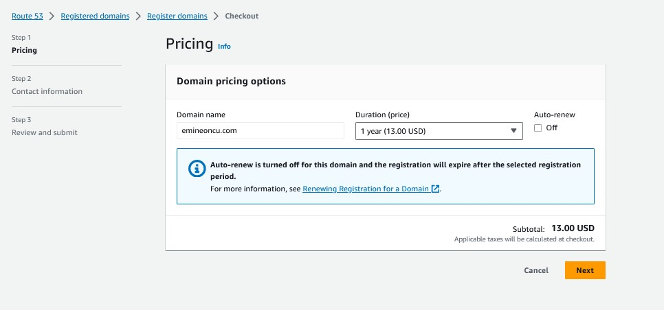

* **Created public website using S3 web hosting.**
* <http://demo-s3-bucket-emine.s3-website-us-east-1.amazonaws.com/>

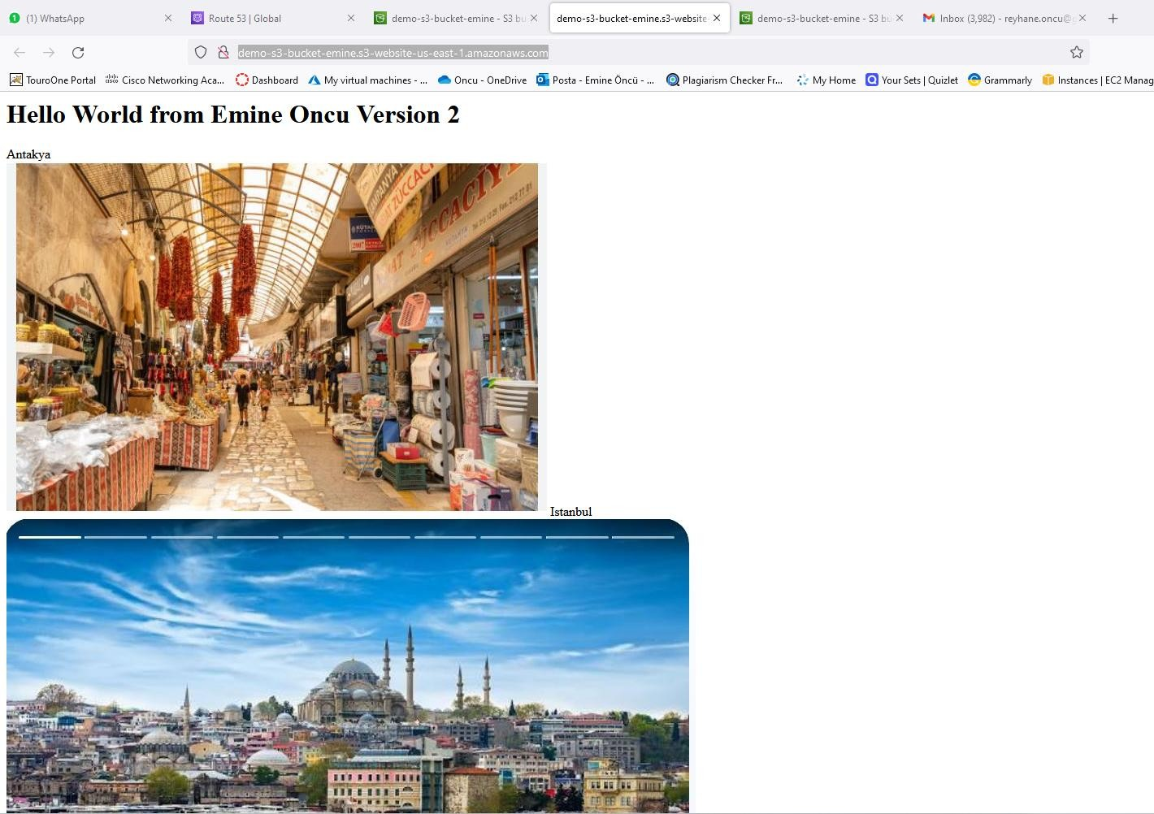

* **Creating a simple “Route 53” for test emineoncu.com routing 11.22.33.44**

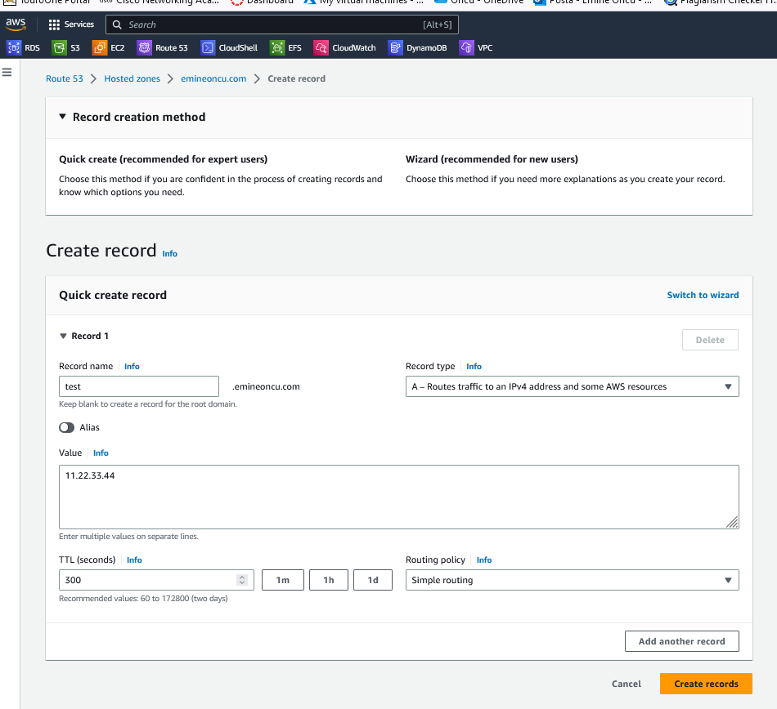

* **Route 53, Hosted Zones section; we can see records.**

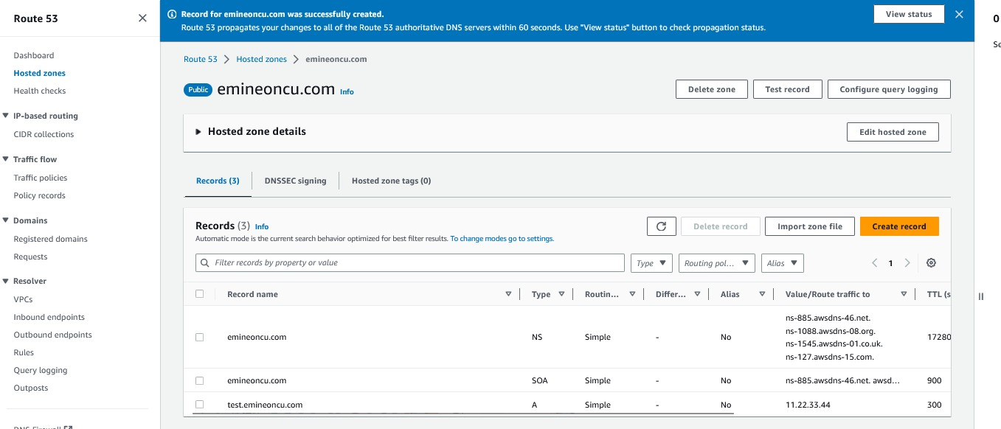

* **Ping test emineoncu.com returns IP address defined for it in Route 53 to record.**

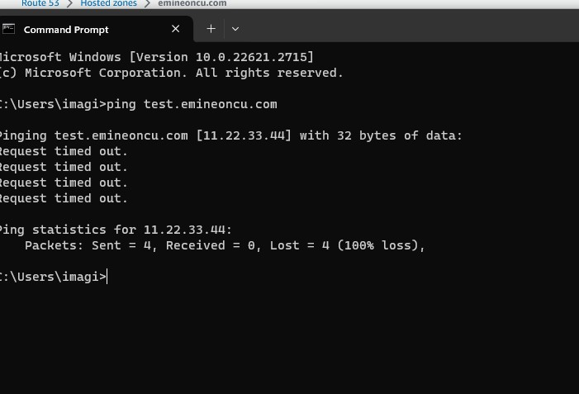

* **Doing an “nslookup” using AWS Cloud Shell:**

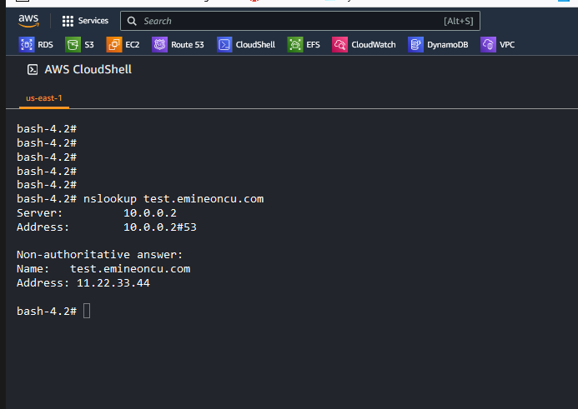

* **Running dig command provides some more information regarding the type of record and the TTL**

(seconds):

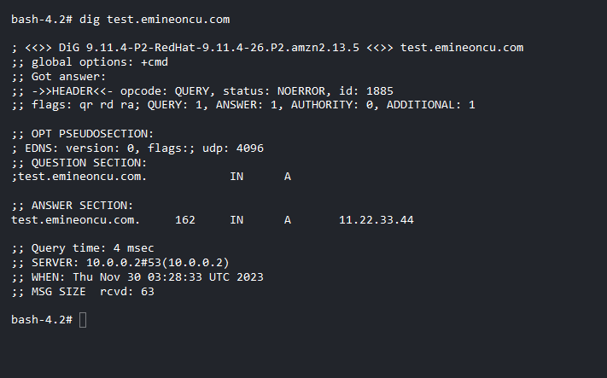

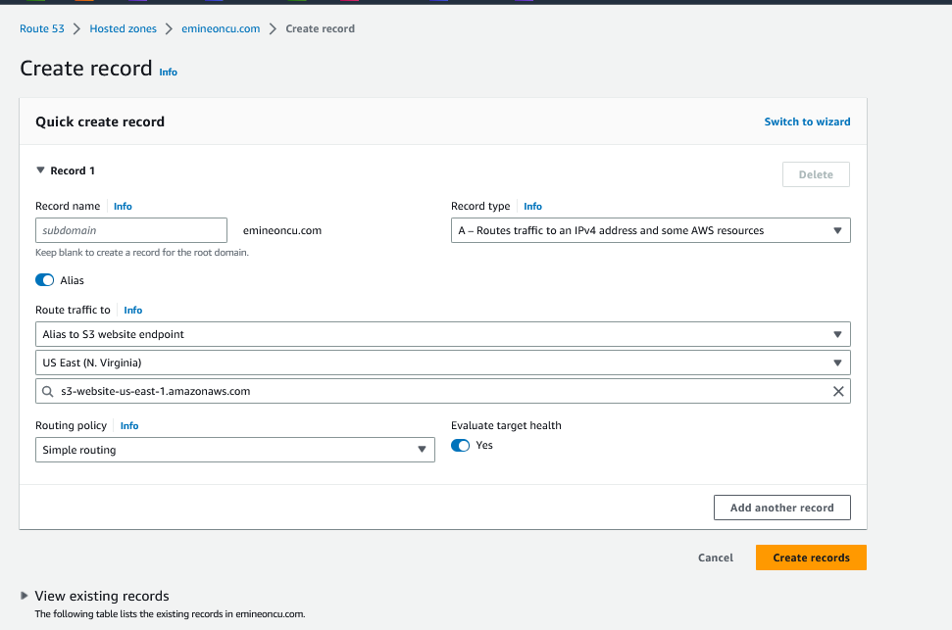

* **Creating an S3 website**
* **S3 bucket name should be the same as website name.**
* **Enable static website hosting.**

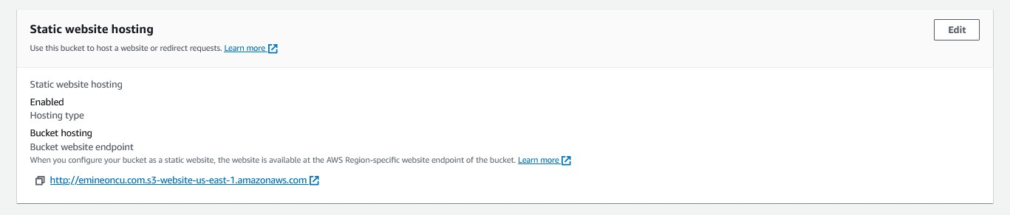

* + **Make the S3 bucket public.**

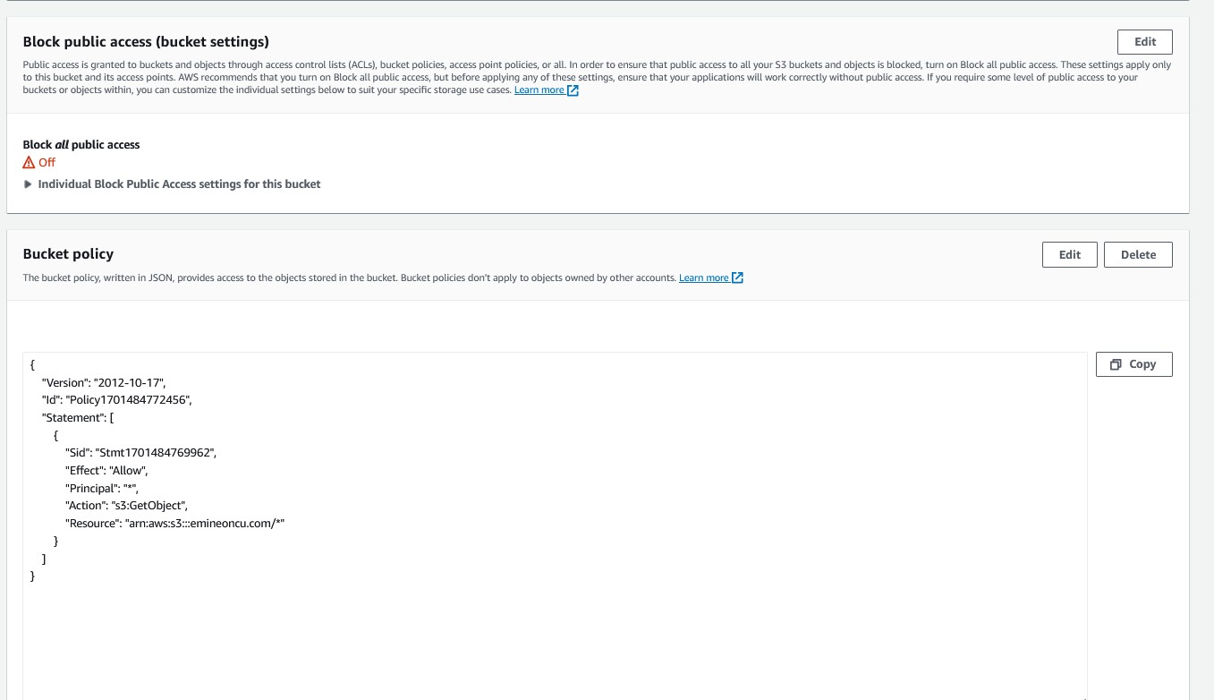

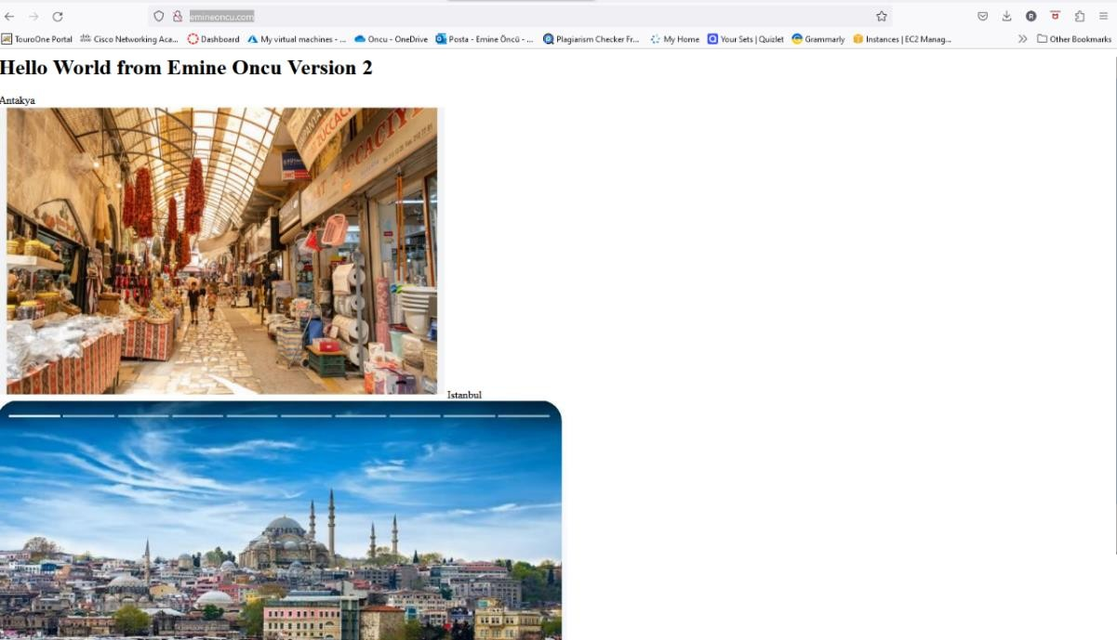

* + **Created a public DNS “emineoncu.com.”**
  + **To enable nslookup using CloudShell**
  + **sudo su**
  + **yum install bind-utils**

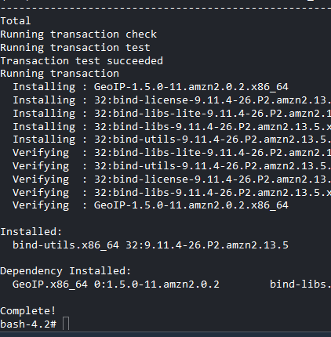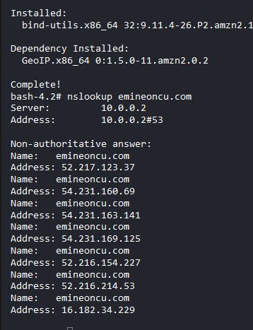

* + **Cloudfront**
  + **Create a Cloudfront distribution instead of making S3 bucket public.**

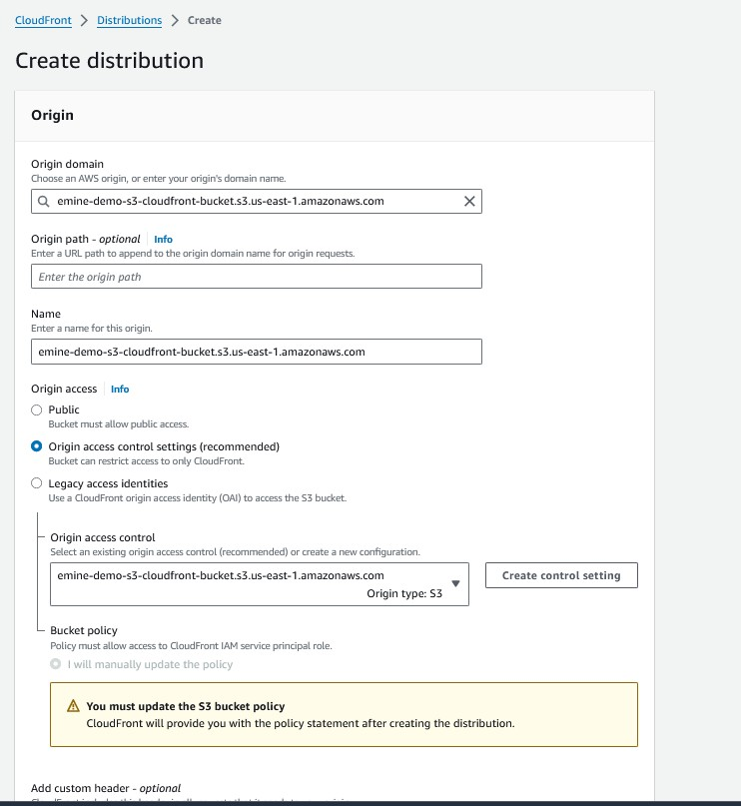

* **Disabling security protection using WAF**

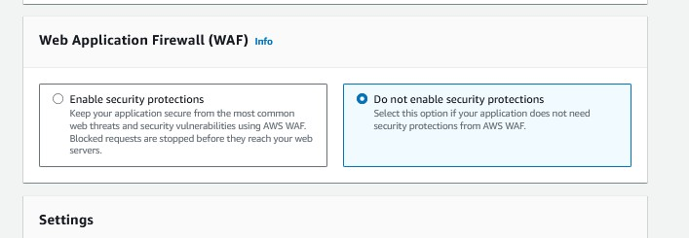

* **Setup a default landing page for our site**

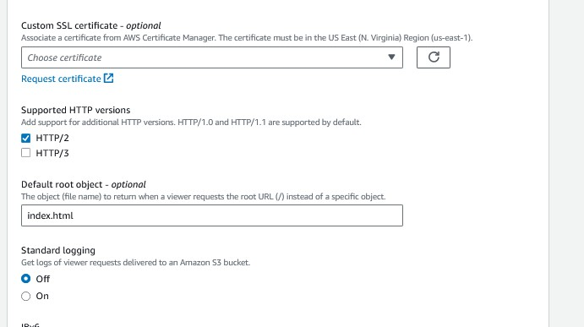

* **Created Cloudfront distribution.**

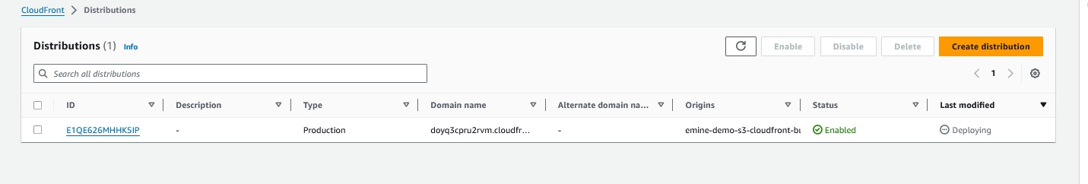

* **Creating a policy to allow Cloudfront to access S3.**

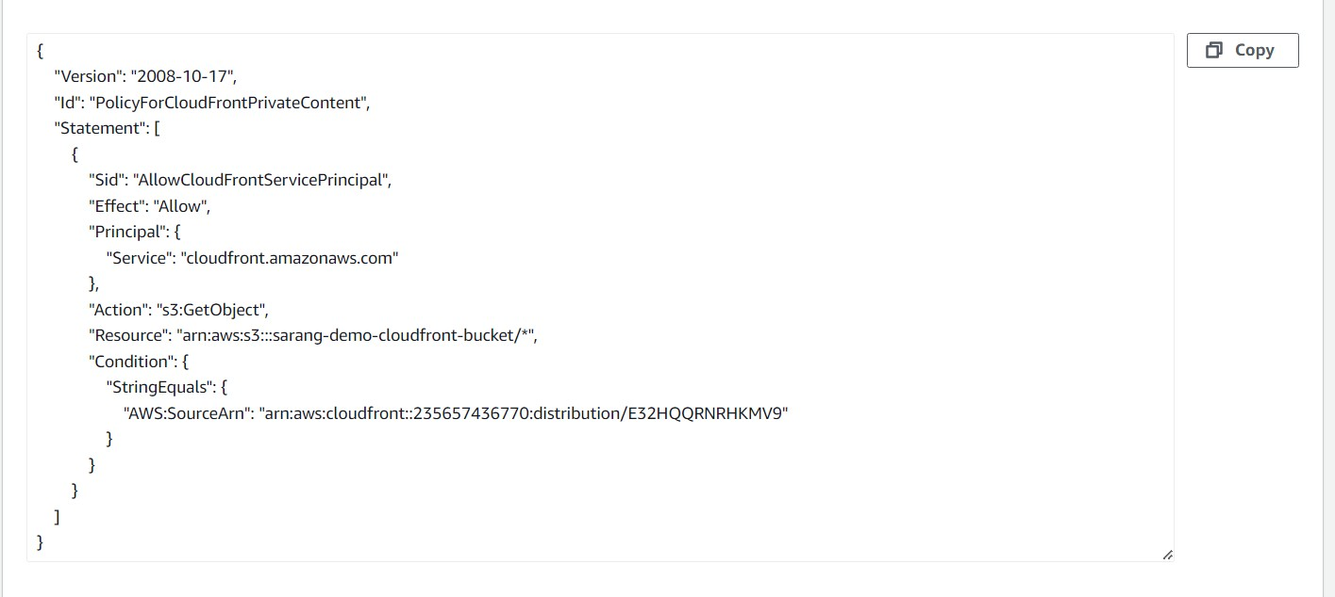

* **Cloudfront URL which serves the content of S3 bucket.**

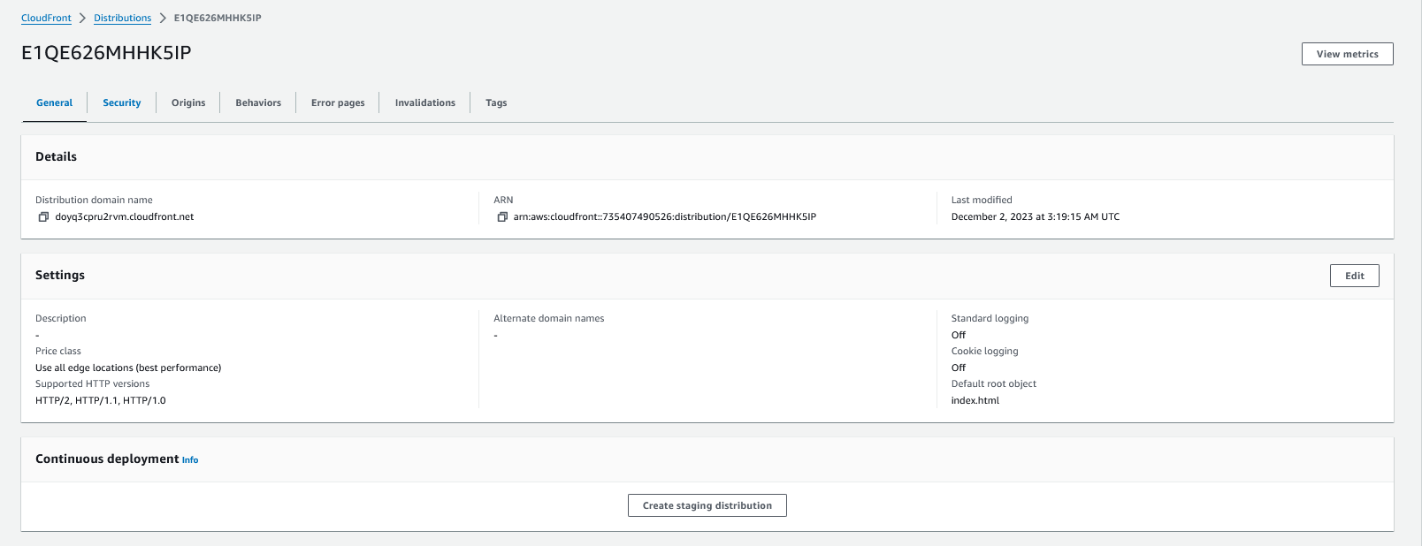

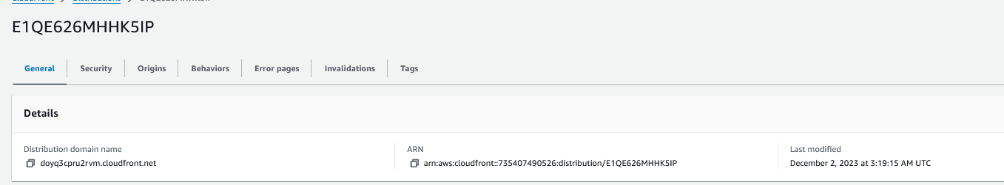

* **Connecting to our website via CloudFront Distribution on private mode. (not public)**
* 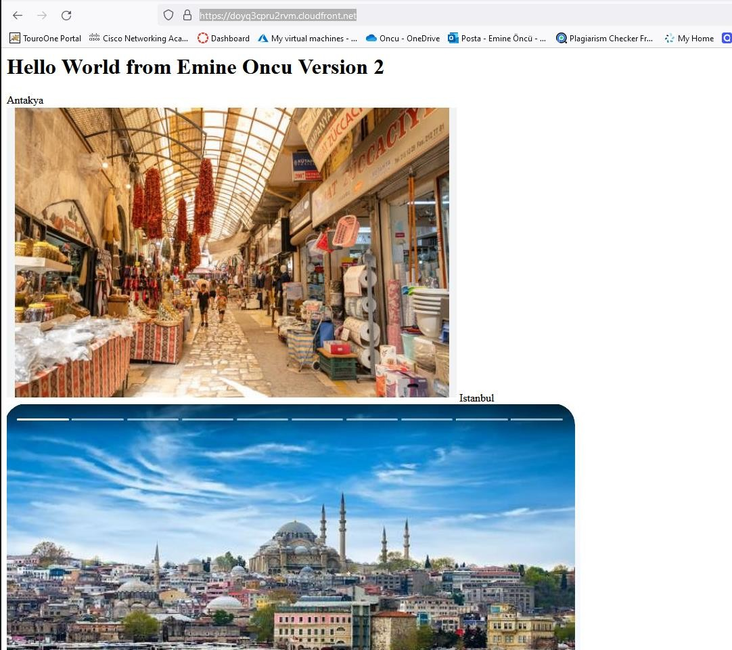**CloudFront URL which serves the content of S3 bucket.**

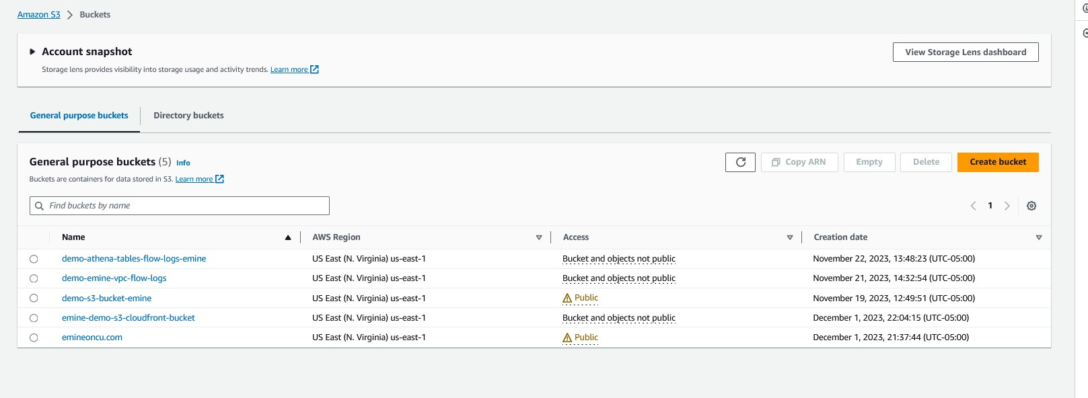

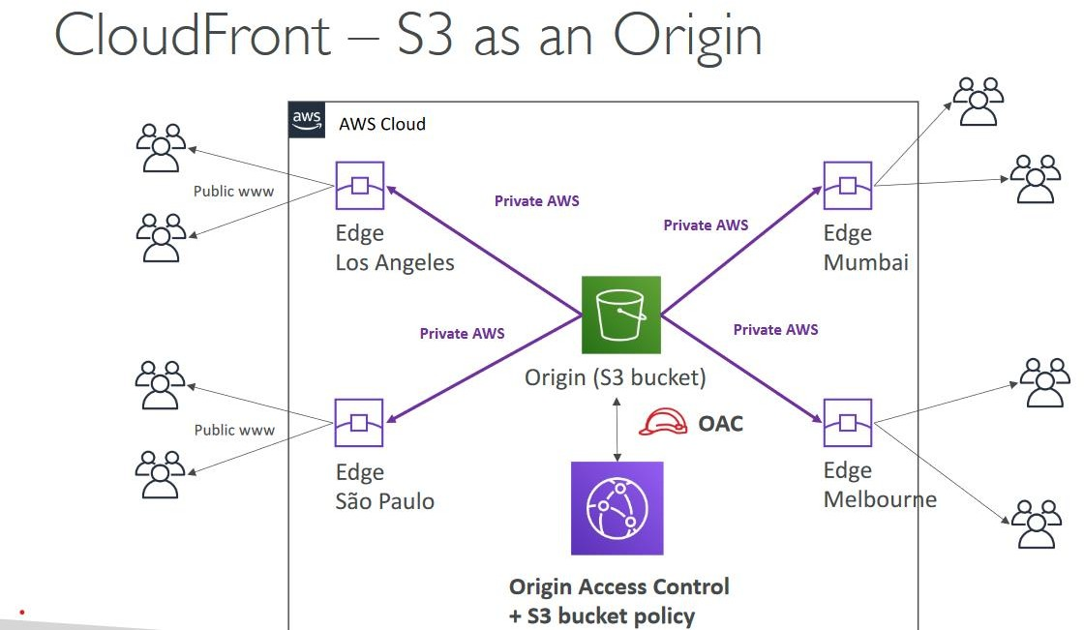

* **ALB as the origin for CloudFront**

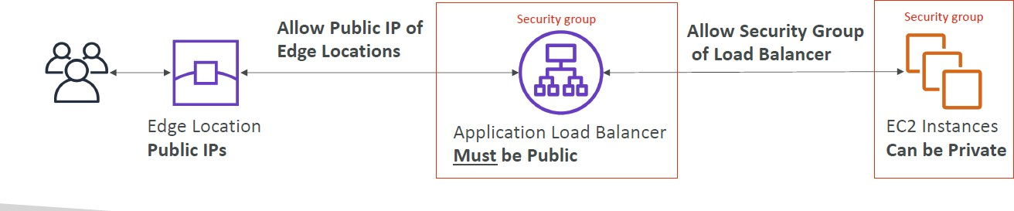

* **We whitelist all the IP addresses for all the edge locations within the ALB, so that when users access the website, the content is served from the edge locations.**
* **Comparison between CloudFront vs Global Accelerator**

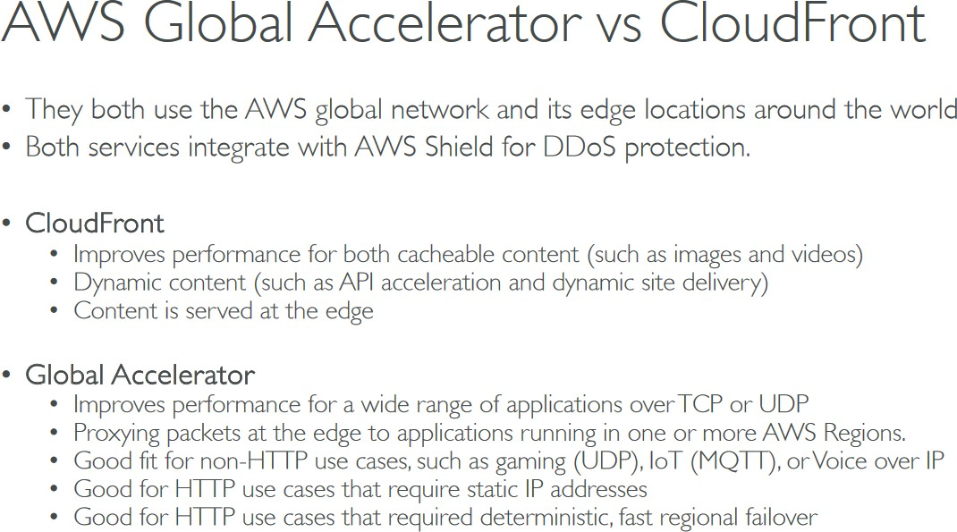

* **EC2 instance launched in Ohio region.**

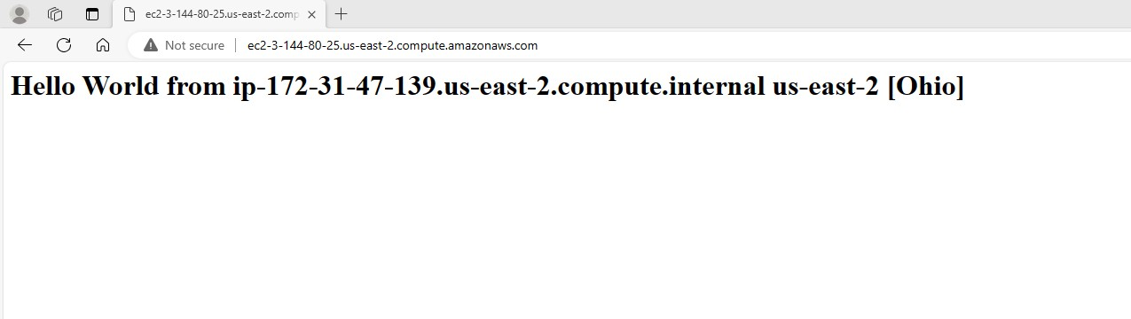

# OHIO DNS NAME: ec2-3-144-80-25.us-east-2.compute.amazonaws.com

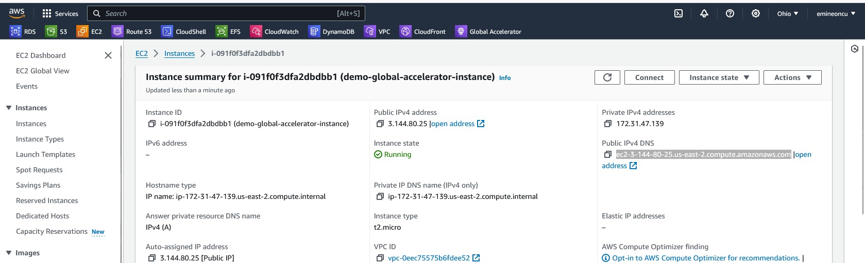

* **EC2 instance launched in Mumbai region.**

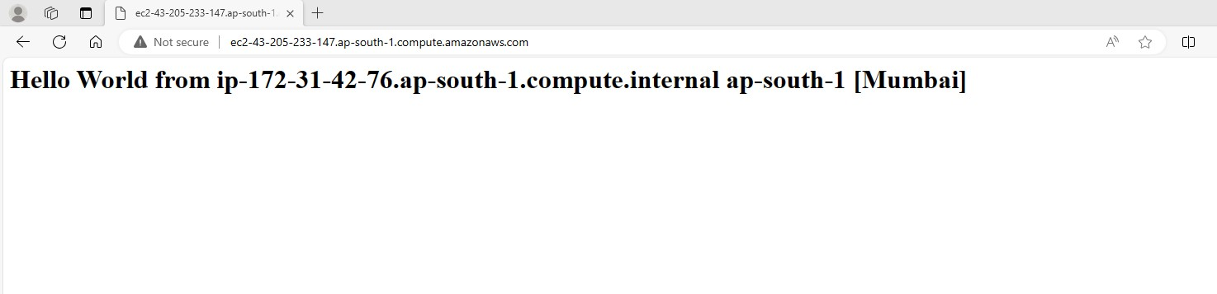

* **MUMBAI DNS NAME: ec2-43-205-233-147.ap-south-1.compute.amazonaws.com**

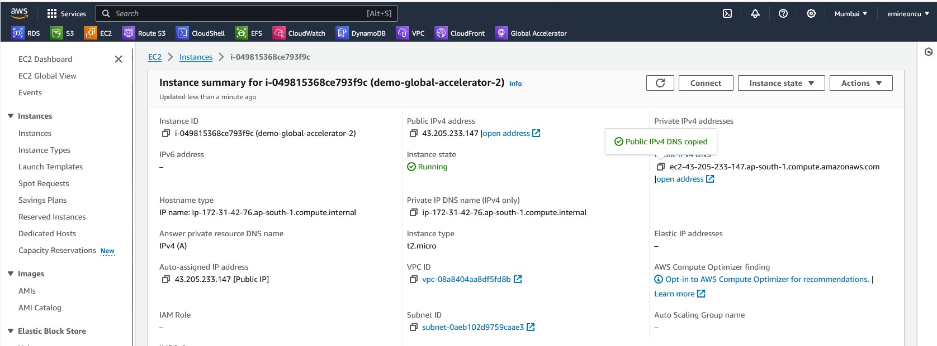

# Creating Global Accelerator

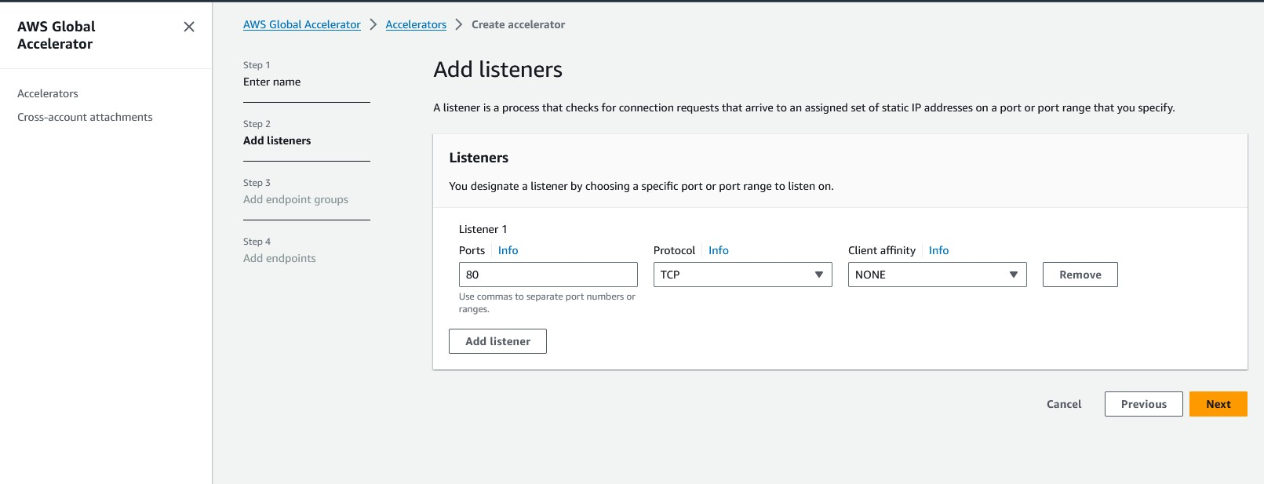

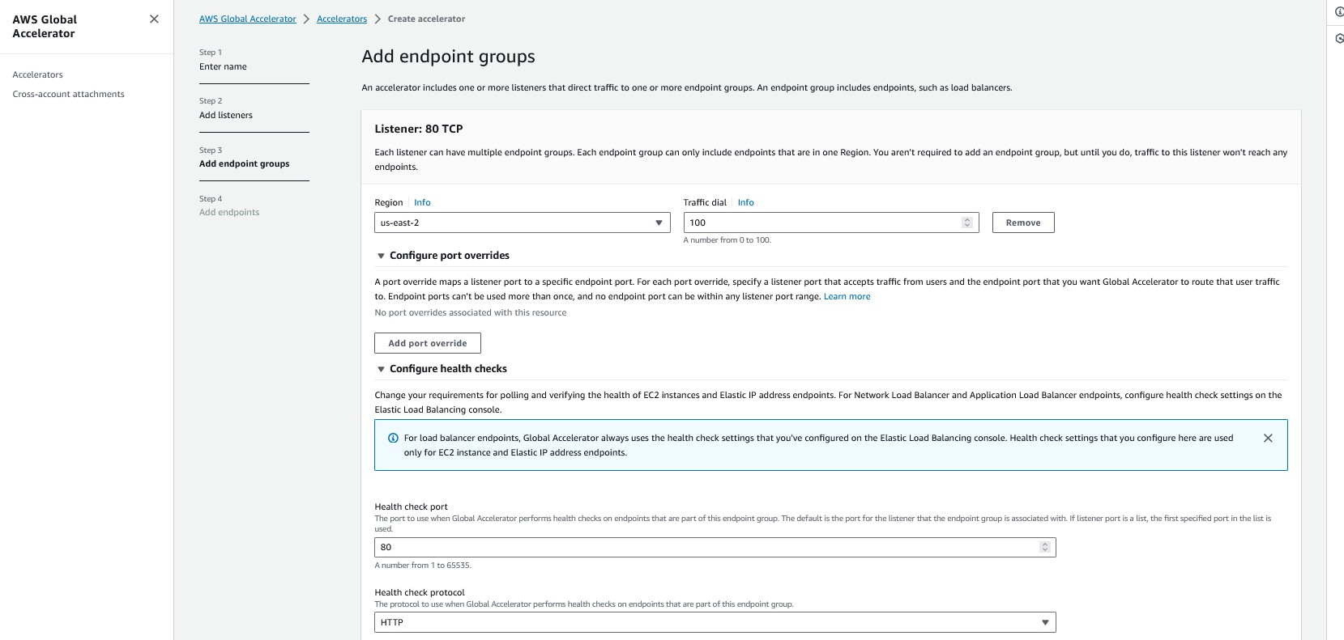

* **Weights are assigned based on business priority.**

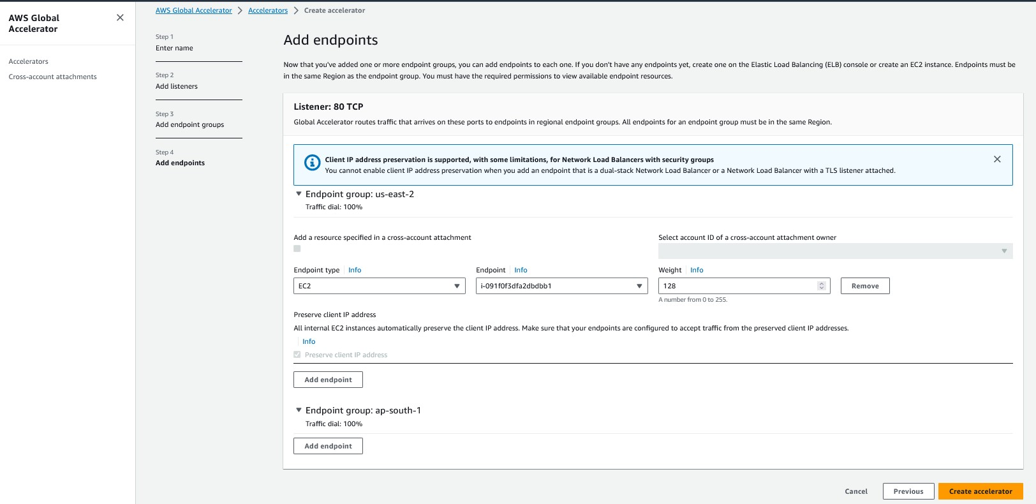

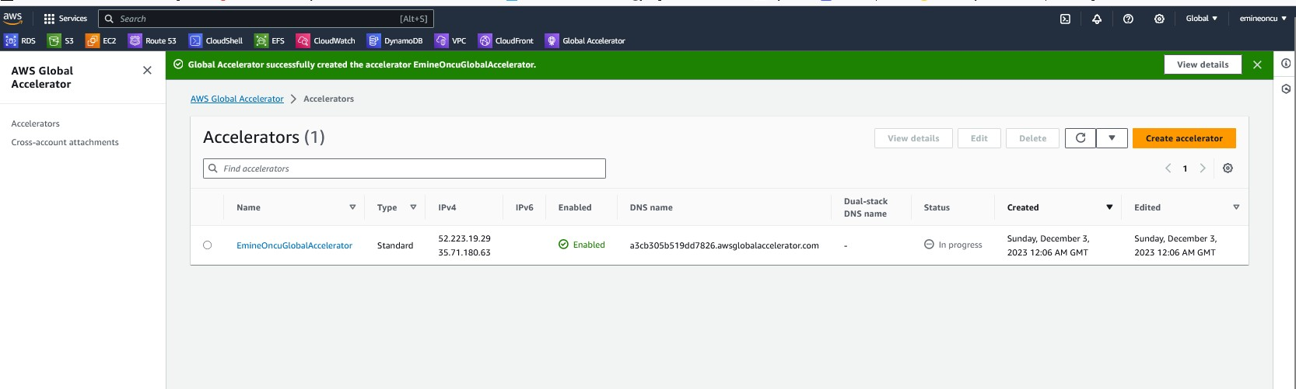

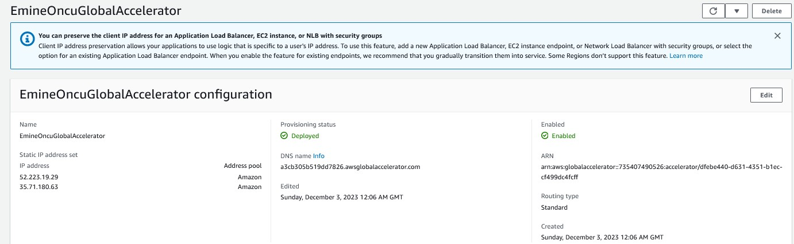

* **Global Accelerator**

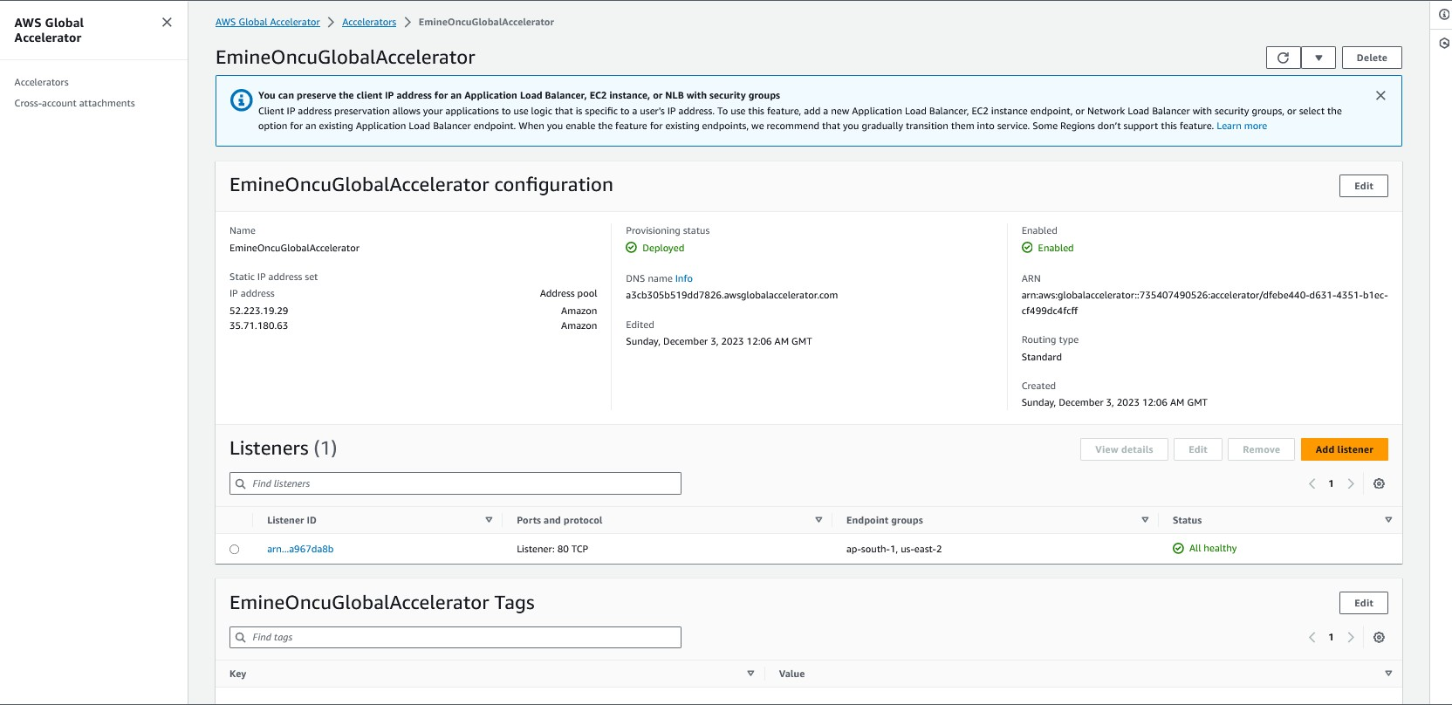

* 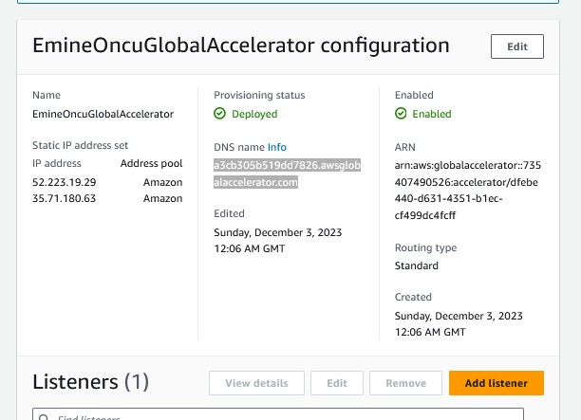**Global Accelerator DNS Name**

# Global Accelerator DNS Open Page

* **NOTE: We set up OHIO Region by default that is why now we are seeing Ohio region serving.**

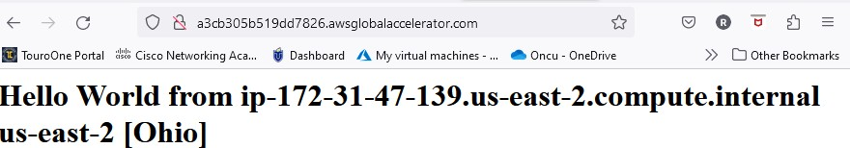

# I changed my location as India (via Singapore), and it has to connect from closest location which is our second location Mumbai.

* **I Used VPN to change my location.**

# If I switch my location back to the USA or nearest any location to USA, it will be reverse and it will start connecting from Ohio.

